# HOME PAGE

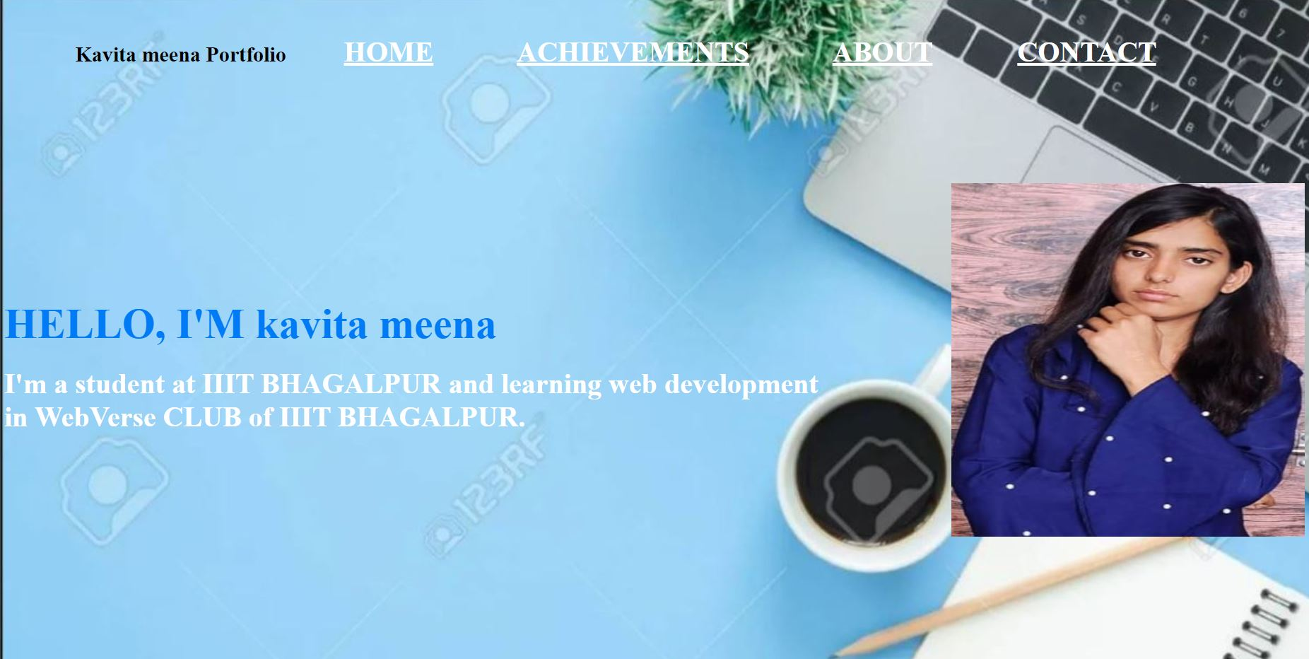

All buttons i.e HOME,ACHIEVEMENTS,ABOUT & CONTACT are responsive and respective page will open on clicking these buttons.

# **ACHIEVEMENTS PAGE**

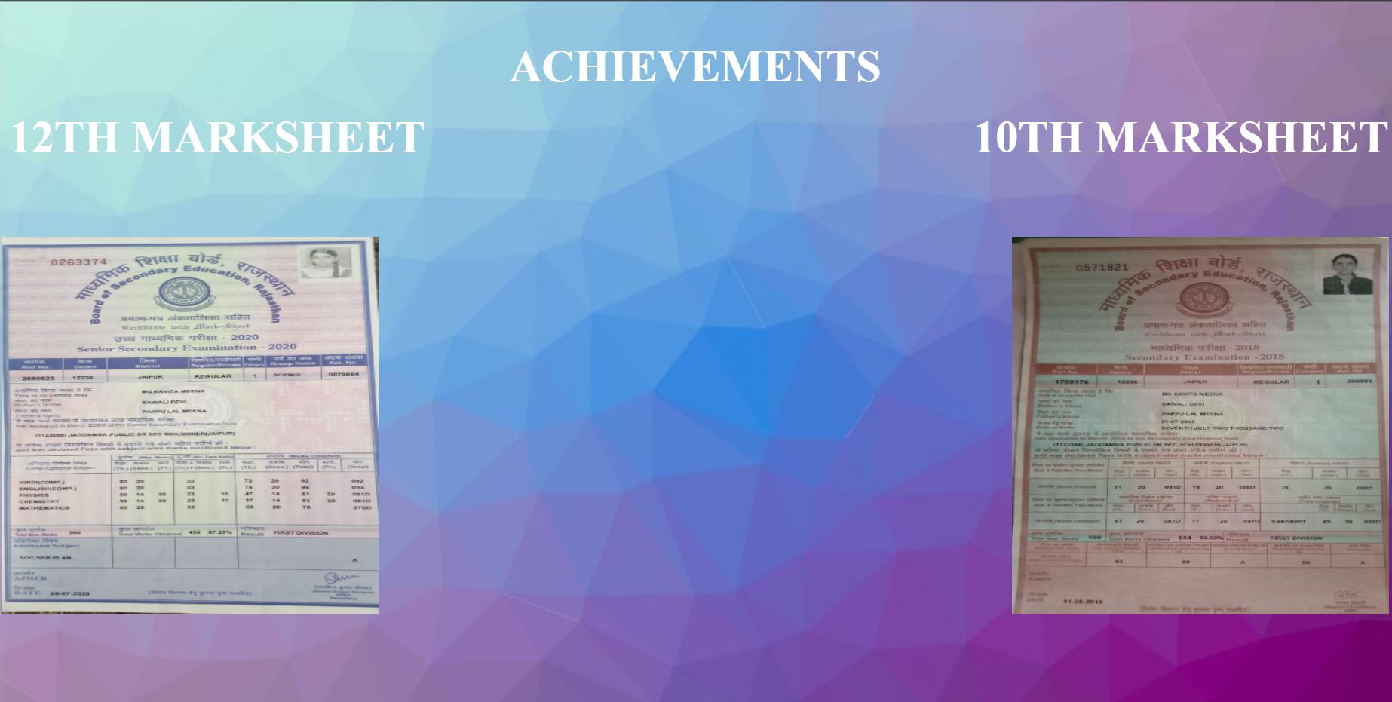

# **ABOUT PAGE**

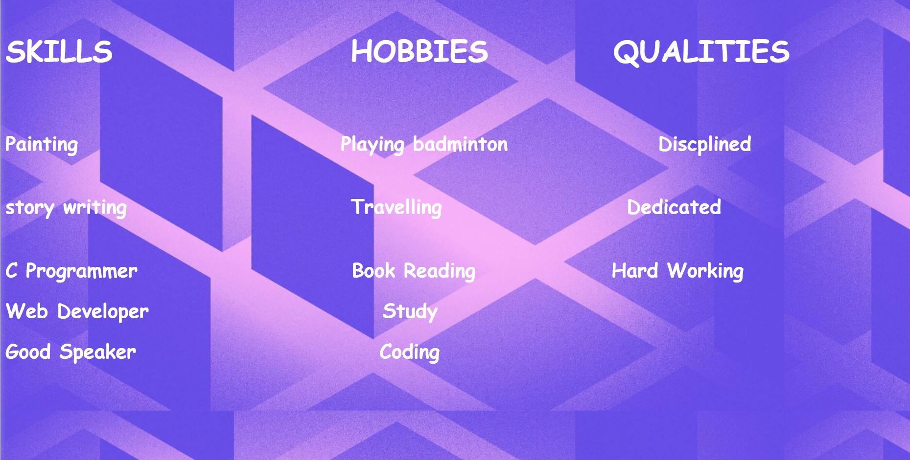

# **CONTACT PAGE**

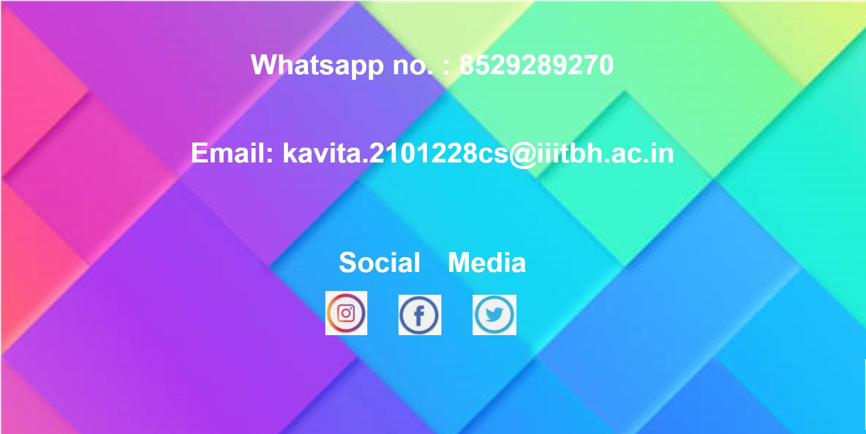

All social media icons are responsive and on clicking them you will be redirected to respective login page.